Test 1: 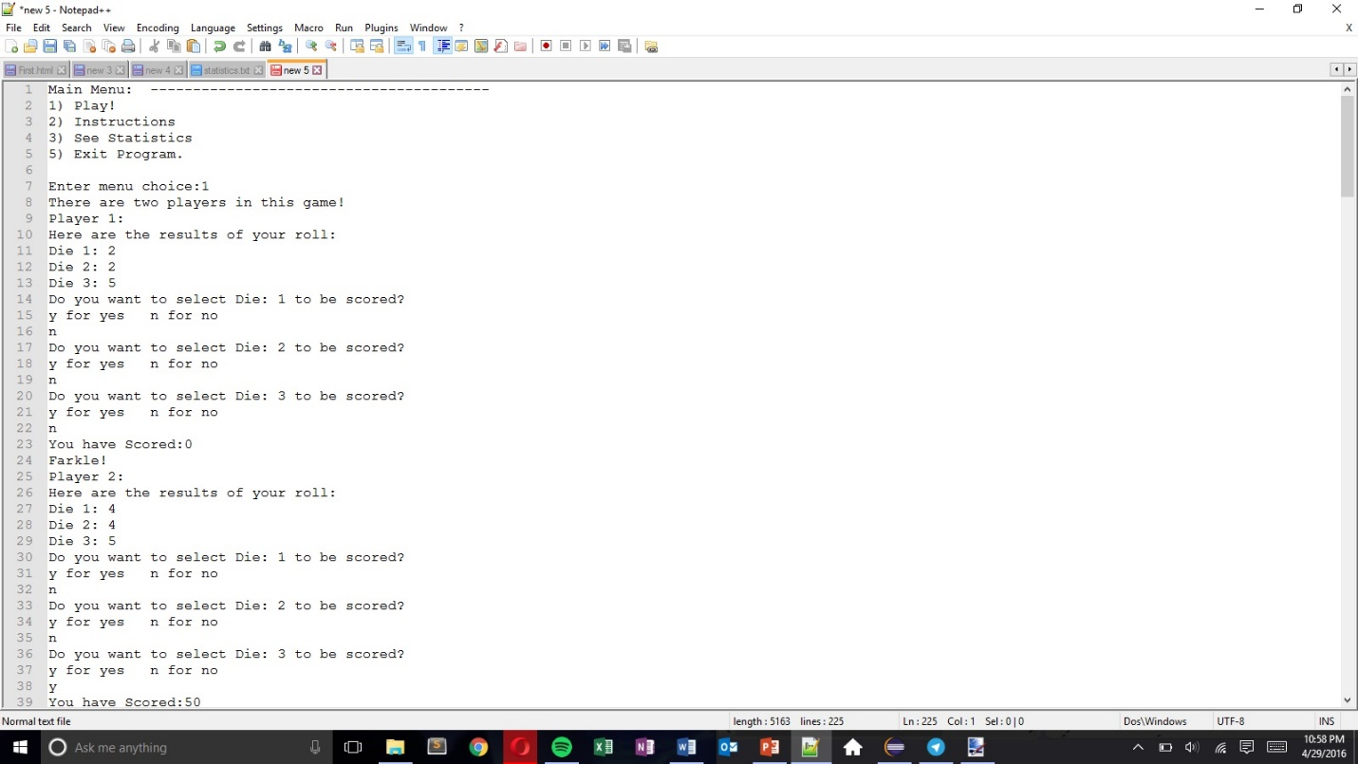

This Test shows that the menu is displayed, and 1 turn for each player. When 1 is selected the game begins and player 1 starts. The dice that he has rolled are displayed and the user is prompted for the dice that he wants. In this test case, the user has not selected any dice and hence is farkled. Player 2 then begins his turn and selects only the third dice. Player 2 has scored 50 points from his selected dice.

Test 2:

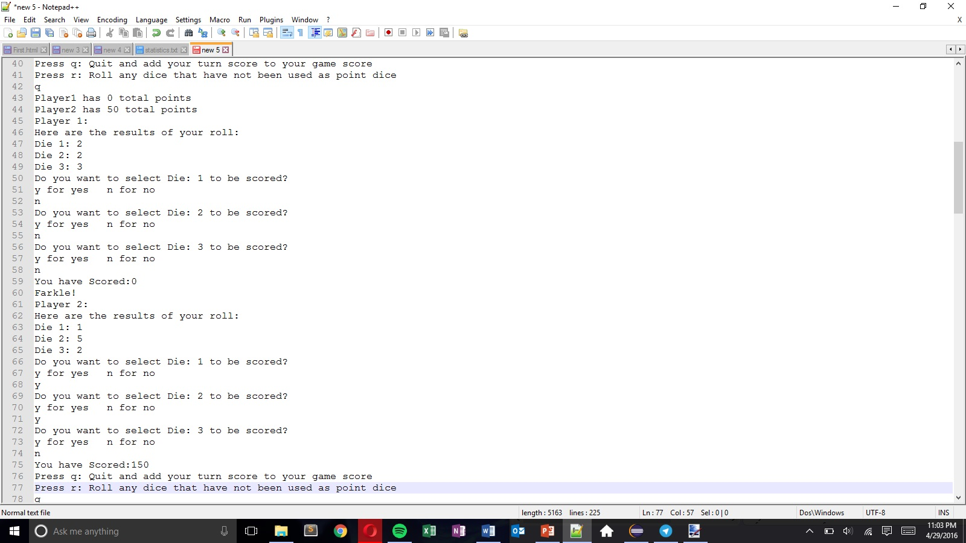

This test shows the remaining portion of the game. Player 2 chooses to keep his points instead of rerolling. Player 1 then begins his second turn. He once again does not choose any dice to be scored and hence farkles again. Player 2 begins his second turn and chooses the first and second die. He scores 150 points for the selected dice and chooses to keep his points again.

Test 3:

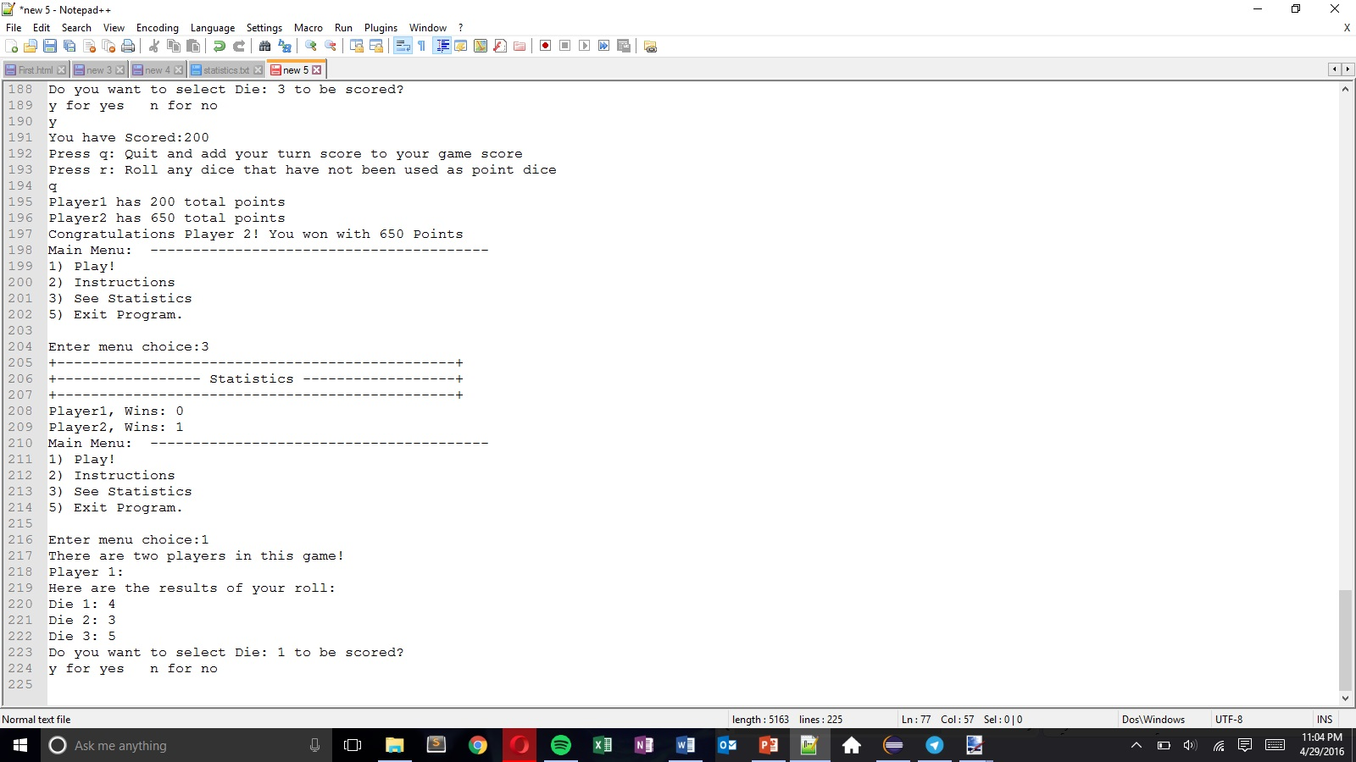

This Test shows the end result of the game. At the end of the game, player 2 scores 650 points which is larger than the required score of 500. Hence he displayed as the winner. The menu pops up again and the user selects the “See Statistics option”. It then shows the updated score that player 2 has won a game.